MID-TERM PROJECT
ETL WITH KAFKA AND HIVE

Name: MOHAMMED ADEEN SHAIK
PROG8451: Big Data integration and storage
Course Instructor: Saber Amini

STEP 1: GETTING API
Getting API key / API token from the NewsApi to fetch values from their archives.
My API key: [REDACTED]
STEP 2: SETTING UP KAFKA BROKER
Running Zookeeper and confluent to start Kafka.
Run this command in the zookeeper directory in your terminal:
bin/zkServer.sh start (make sure your broker ID and everything else is correct in config)
Run this command in the confluent directory:
bin/kafka-server-start etc/kafka/server.properties
STEP 3: SETTING UP JUPYTER NOTEBOOK TO RUN KAFKA PRODUCER AND CONSUMER
I am going with Jupyter Notebook to run my Python script for Kafka producer and consumer files.
I am fetching values of keyword= “apple “, to get news articles related to the apple company. Also, I am skipping all the articles that were removed or deleted.

PRODUCER:
[Producer screenshot removed because it exposed a service credential.]CONSUMER: 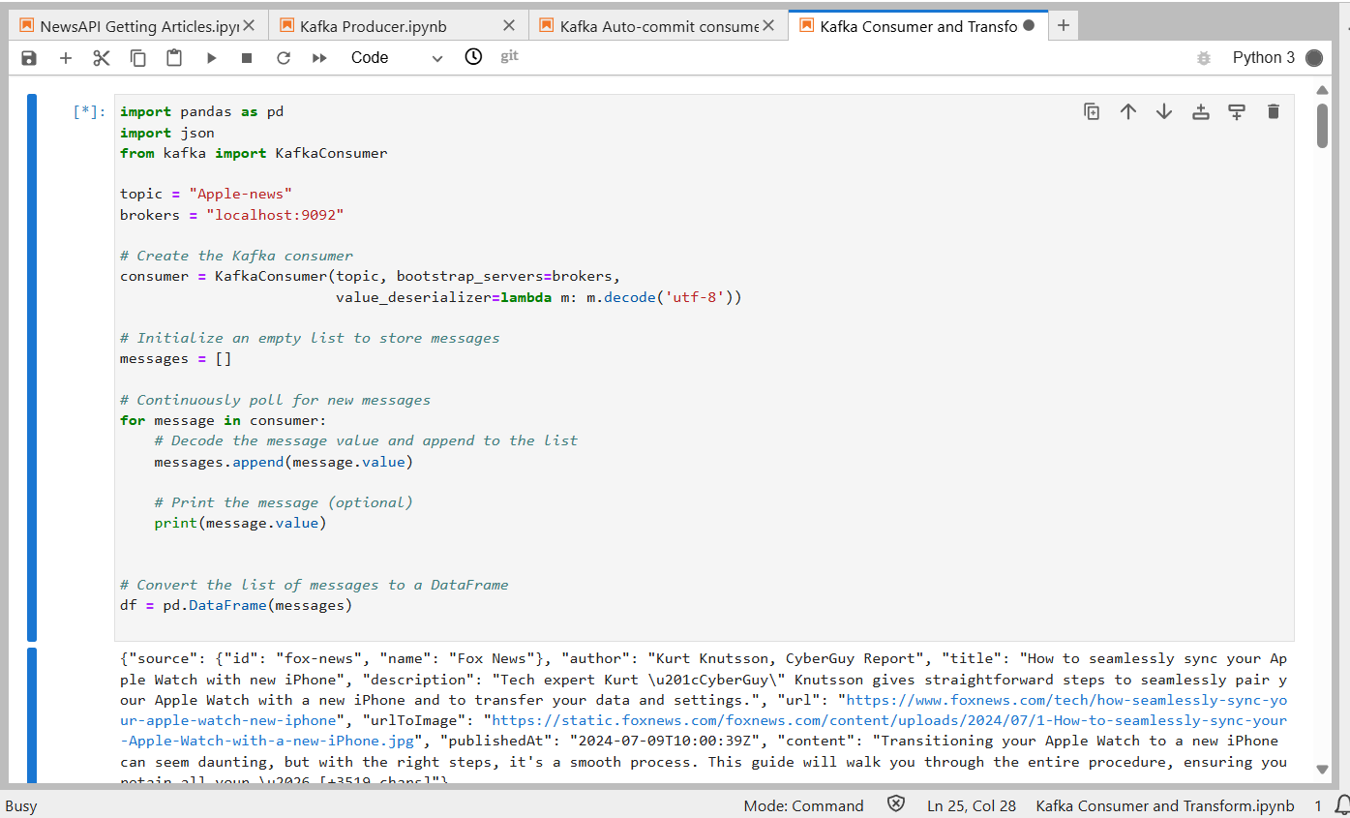
STEP 4: Setup a Kafka Consumer to read the data:
Since I added this Jupyter notebook component to my cluster: etl-mid-term-project
I will process and send this data as a CSV file with name as ‘news.csv’ to my local directory:
Preprocessed data:
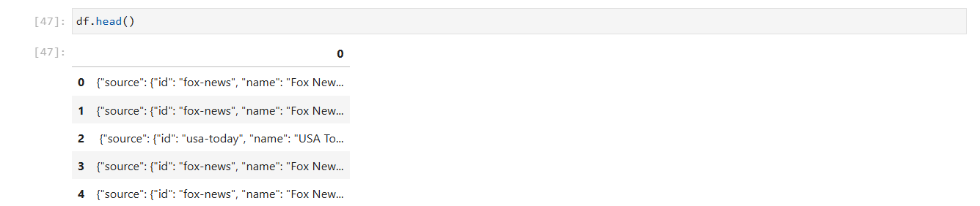
Processed data:
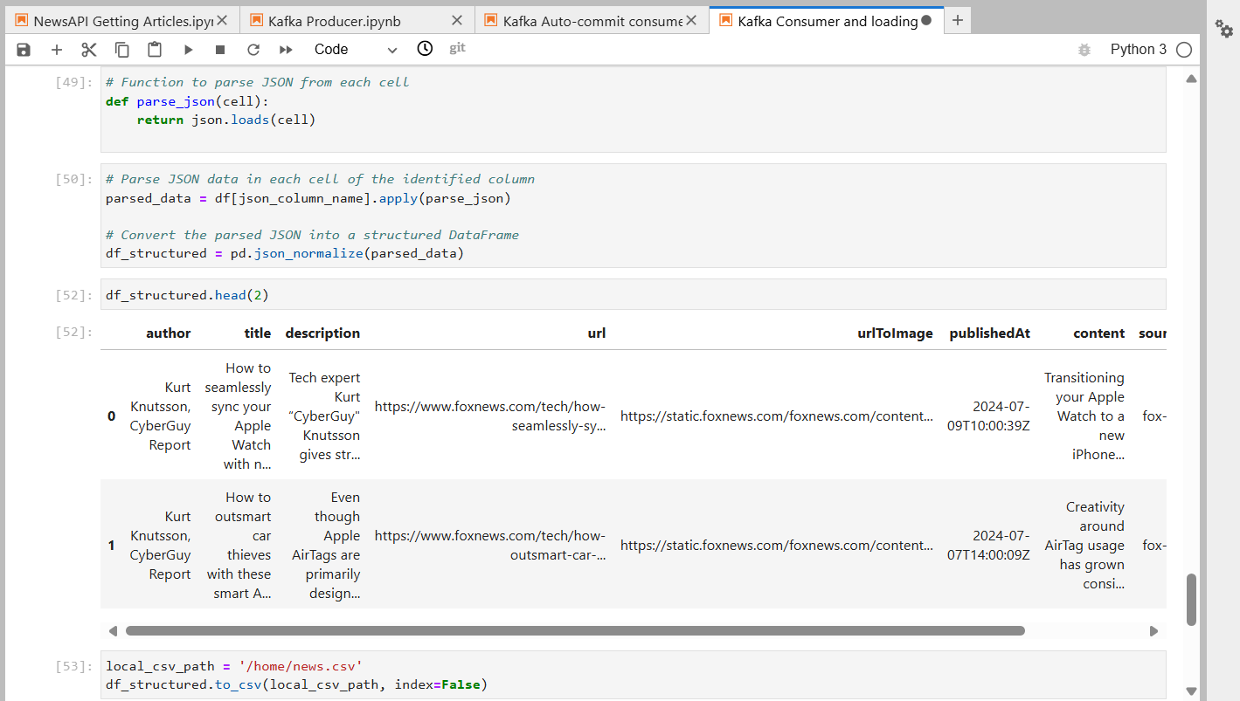

Next, Check-in your local directory where you saved the data as CSV file.:
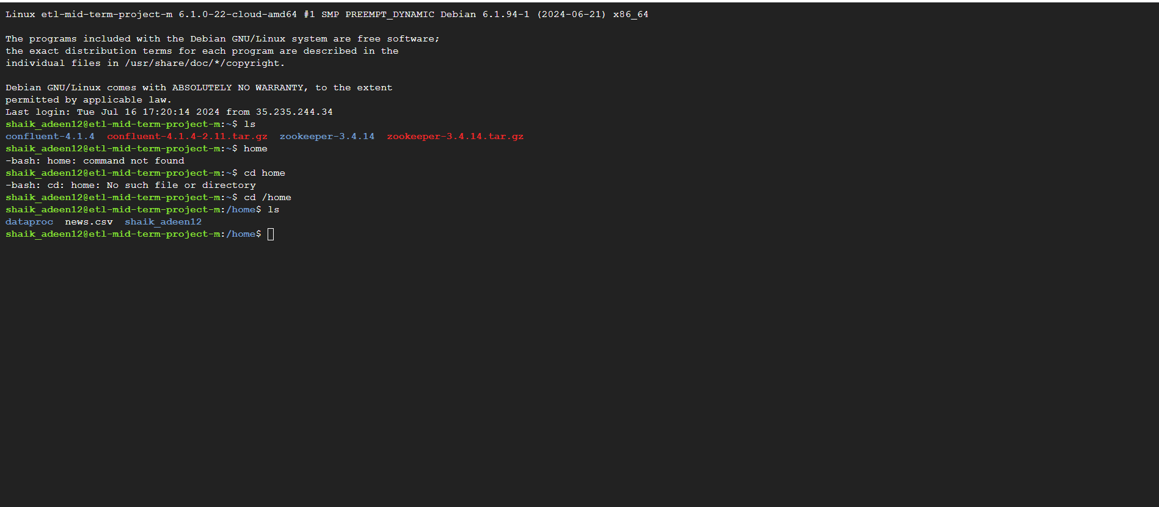

Now that a hive table has been created we will run a few queries to study the data and gain information.
Now we upload this news.csv file to the HDFS directory: /hive/midterm-project/
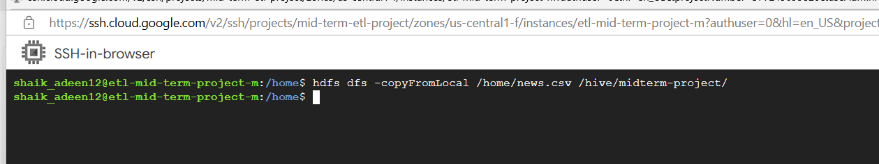
Check if it is in the Hadoop directory:
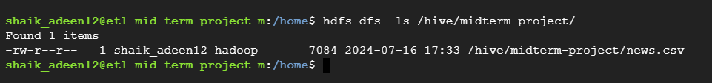

Step 5: Load the CSV to HIVE and run queries to gain insight on the data.
Hive table ‘apple_news’ using news.csv:
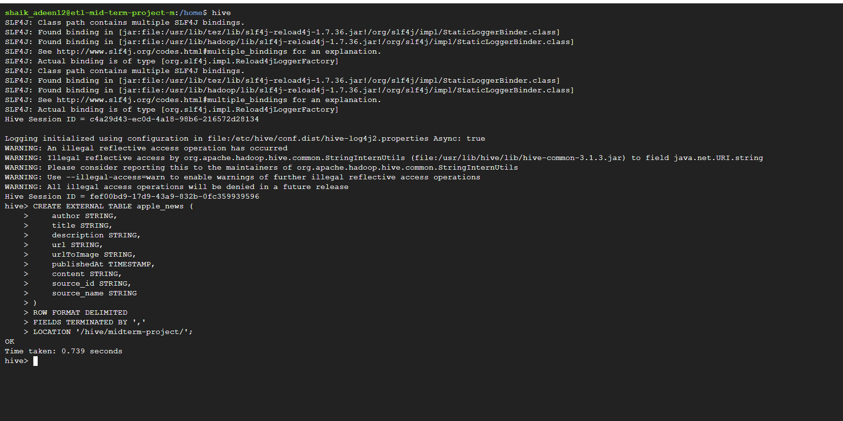
With this a hive table is made and now we can run our queries:
QUERIES:
1. Query to count the number of records / articles :
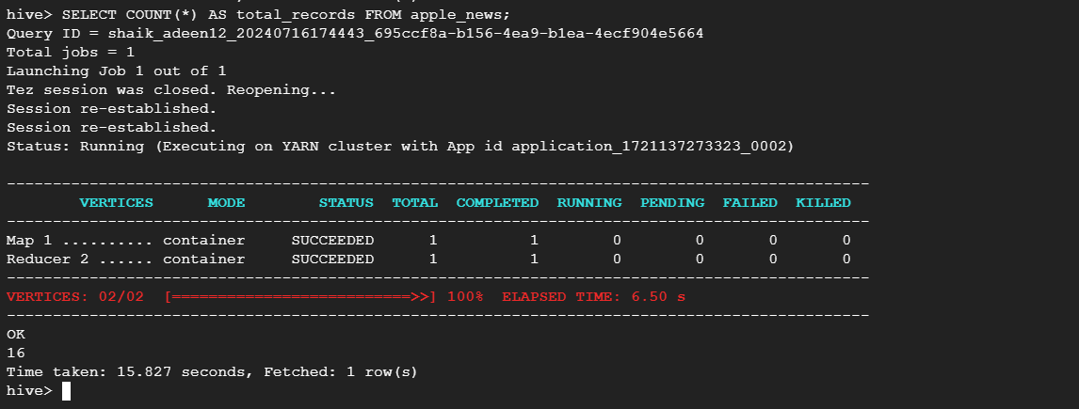
There are 16 articles or records/ rows

2. Query to List top 10 authors by the number of articles:
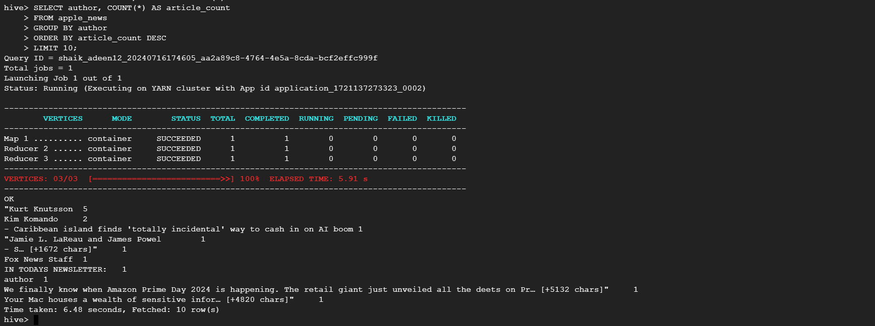
These are the authors with their articles count.

3. Query to Find the most frequent sources:
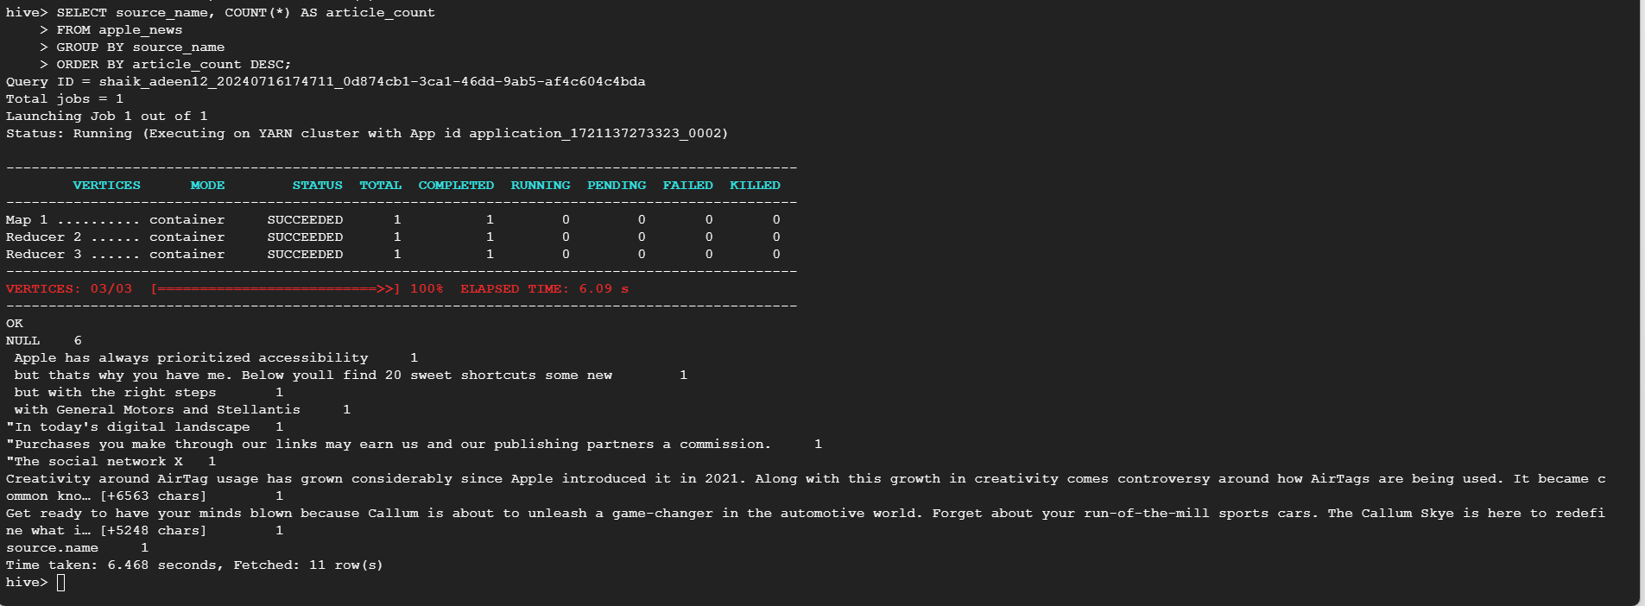

4. Query to List articles with the longest content:
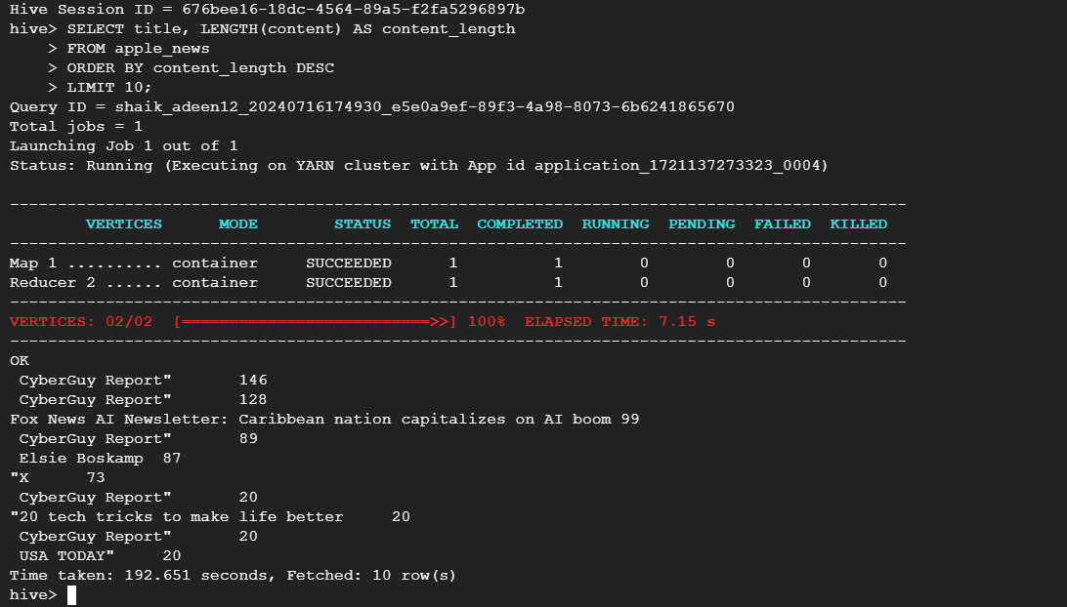
This query shows the top 10 articles with the length of content.

CONCLUSION:
This ETL project utilized the NewsAPI to fetch news articles about Apple, streaming them through a Kafka broker. I efficiently transferred the data to a Hive table using a Kafka producer in a Jupyter Notebook within my Hadoop cluster on GCP. By querying the apple_news table in Hive, I gained valuable insights into article trends, authors, sources, and content characteristics. This project demonstrates the effectiveness of Kafka and Hive for real-time data ingestion, storage, and analysis in cloud environments.

THANK YOU

